Image Processing – Denoising

Introduction

Visual Information transmitted in the form of digital images is a major method of communication in the modern age, but the image is often corrupted with noise. The image that is received needs to be restored to remove the noise before it can be used in applications. The method of restoration involves the processing of the image data to produce an image that is more discernable and of a visually higher quality.

Background Theory

Digital images are of vital importance in the fields of research, technology, information systems and medical science. When an Image is captured various forms of degradation may occur such as blurring or noise due to factors such as electronic and photometric conditions. Noise in an image is caused by unwanted signal that interferes with the original scene or by an optical system that is out of focus. Image denoising refers to the pre-processing step that aims to restore much of the degradation in an image before any further image processing is carried out.

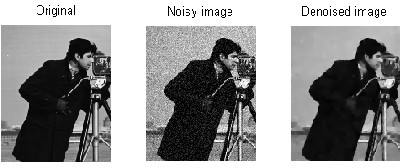

Types of Noise

1. Gaussian Noise

Gaussian noise is evenly distributed over the signal. It is statistical noise having a probability density function equal to the normal distribution. This means that each pixel in the noisy image is the sum of the true pixel value and a random Gaussian distributed noise value.

 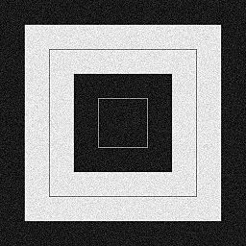

Without Noise With Gaussian Noise

1. Salt and Pepper Noise

Salt and Pepper is an impulse type of noise and is also referred to as intensity spikes. It presents itself as sparsely occurring white and black pixels. It is generally caused due to errors in data transmission. The corrupted pixels are set alternatively to either a minimum or to a maximum value.

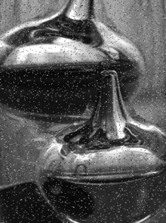Image with “Salt and Pepper” Noise

1. Speckle Noise

Speckle noise is multiplicative noise. The vast majority of surfaces, synthetic or natural, are extremely rough on the scale of the wavelength. This type of noise occurs in images obtained from these surfaces by coherent imaging systems such as laser, synthetic aperture radar (SAR), and ultrasound imagery.

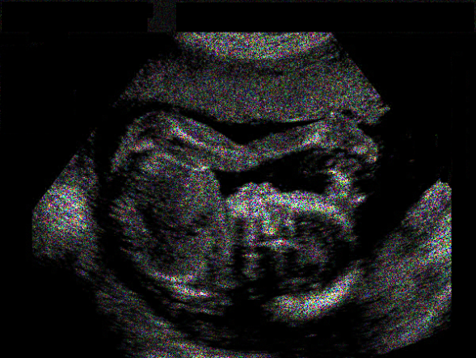 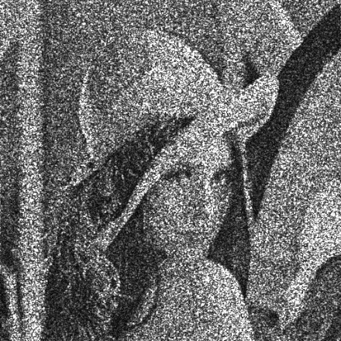

Images with speckle noise.

Problem Statement

This report is set out to restore an image with Gaussian Noise.

A method called Spatial Domain Filtering is used to de-noise the image. It involves applying a mean filter on an image to smoothen it, this reduces the intensity variation between adjacent pixels.

This is accomplished by means of convolution between a kernel and an image to achieve the effects such as blurring, sharpening, embossing and edge detection.

Convolution works by determining the value of a central pixel by adding the weighted values of all its neighbors together. This process is applied to all pixels in the image and the result obtained is the new modified filtered image.

For example:

   

In this example we apply a convolution to the pixel value (201).

This is shown below:

New pixel value.

$\left[\begin{matrix}164 & 188 & 164 \\ 178 & 201 & 197 \\ 174 & 168 & 181\end{matrix}\right]*\left[\begin{matrix}0 & 1 & 0 \\ 1 & 1 & 1 \\ 0 & 1 & 0\end{matrix}\right]=\frac{932}{5}$

Divide by the sum of the kernel elements.

With a growing demand for digital images with higher resolution this method of Spatial Domain Filtering becomes extremely expensive with regards to the time taken to execute the convolutions. This report presents comparative analysis solutions of both serial and parallel implementations of restoring an image with Gaussian Noise.

Proposed Solution Overview

The first step will be to convert the image into a matrix representation of its pixel color values.

 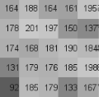

A process of edge extrapolation will then have to be applied to our image before any calculations are carried out. This process will add a border of “false pixels” to the edge of our image and thus enable us to be able to apply our kernel matrix to the edge pixels of our original image.

 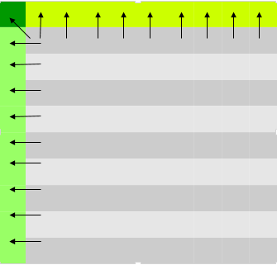

Two versions of implementing Spatial Domain Filtering will be carried out for analysis. A serial implementation and a parallel implementation.

The solution will explore different kernel settings within the two methods of implementation in an attempt to improve computation time and resulting image quality.